**PRACTICAL 0**

Install DNS server BIND, Configure DNS server which resolves domain name or IP address, Install BIND 9, Configure BIND, Limit ranges You allow to access if needed.

SERVER:

Run the following command to install BIND9 and its related packages:

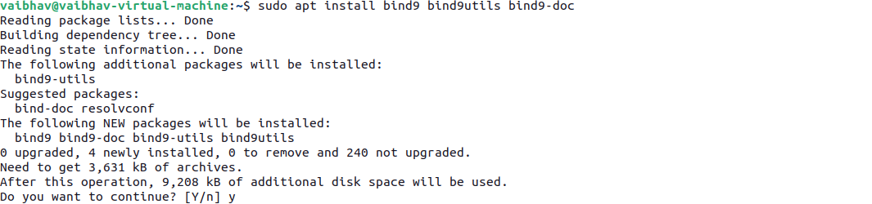

Edit the /etc/bind/named.conf.options file to set DNS forwarding, and adjust other settings if necessary:



Add or modify the forwarders section to specify upstream DNS servers for unknown queries:

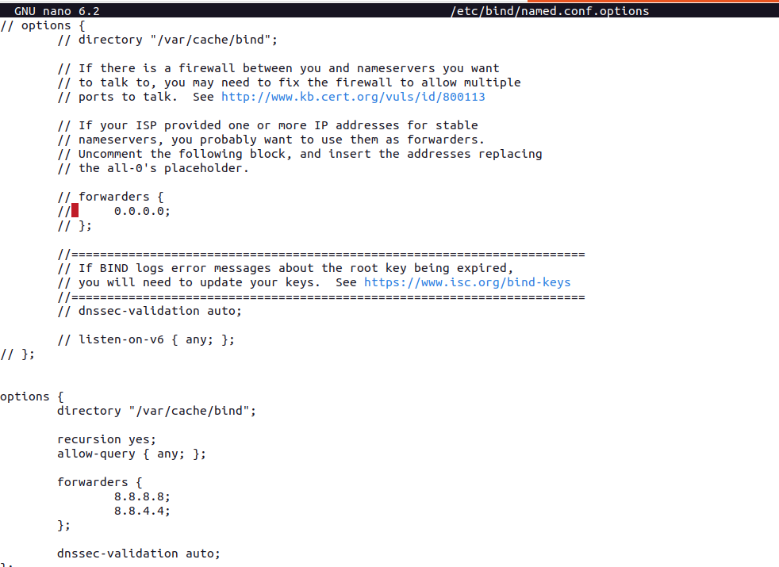

Define your domain zone in the /etc/bind/named.conf.local file:



Add the following lines to configure a forward and reverse lookup zone:

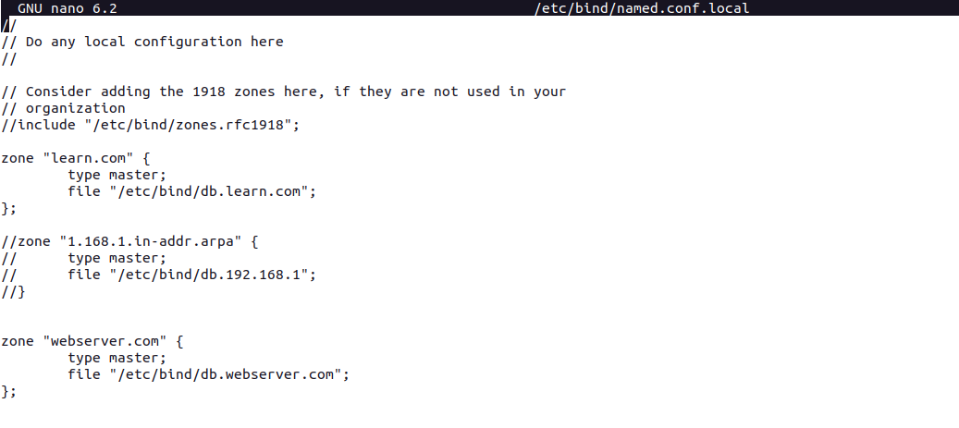

Create the forward zone file for your domain:





Modify the file with your domain details:

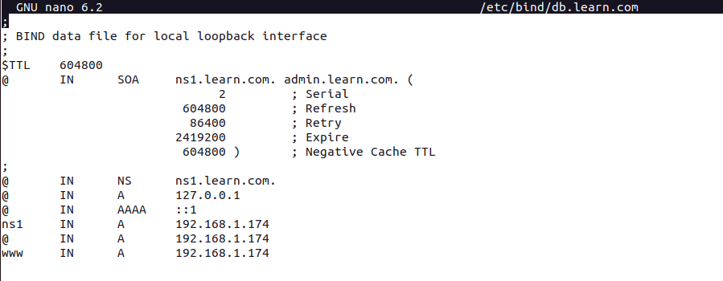

Ensure the following ports are open:

* **Port 53** for DNS queries.
* **Port 80** for HTTP.
* **Port 443** for HTTPS.

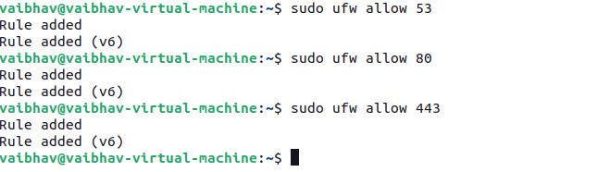

If no errors are found, restart the BIND9 service:



CLIENT:

Configure the IPV4 Properties and add the DNS server IP

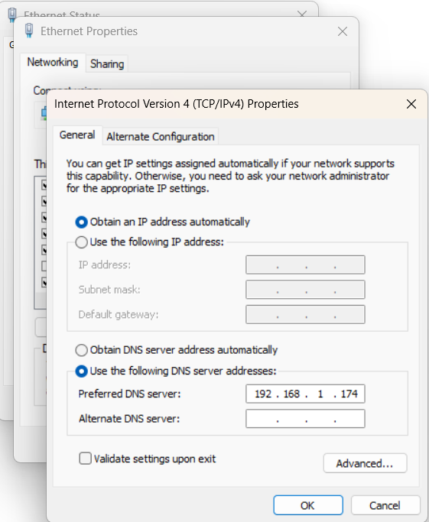

You can now access the websites configured in zone

